|  |  |  |  |  |  |  |  |
| --- | --- | --- | --- | --- | --- | --- | --- |
| **Date:** | **27-05-20** | | | | **Name:** | **SAHANA C** | |
| **Sem & Sec** | **VI B** | | | | **USN:** | **4AL17CS116** | |
| **Online Test Summary** | | | | | | | |
| **Subject** | | **SCCD 2 IA Test** | | | | | |
| **Max. Marks** | | **30** | | **Score** | | **22** | |
| **Certification Course Summary** | | | | | | | |
| **Course** | **Front end development in HTML** | | | | | | |
| **Coding Challenges**  1)write a c program to sort an array of integers in ascending order and display the sorted array and number of passes performed for sorting  2)Python Program to print all the nos not divisible by either 2 0r 3 and lies between 1 to 50 | | | | | | | |
| **Certificate Provider** | | | **Great learning** | **Duration** | | | **6DAYS** |
| **Status:Completed** | | | | | | | |
| **Uploaded the report in Github** | | | | **Yes** | | | |
| **If yes Repository name** | | | | https://github.com/sahanasanu/Daliy-status | | | | |
|  | | | | |
| **Uploaded the report in slack** | | | | **Yes** | | | |

**DAILY ONLINE ACTIVITIES SUMMARY**

**Ce Certification Details**

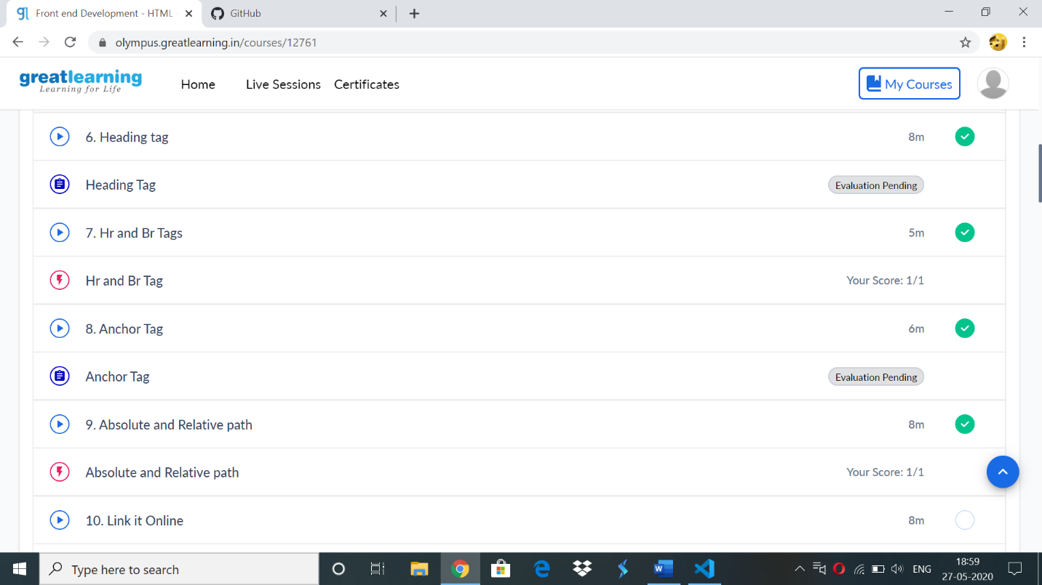

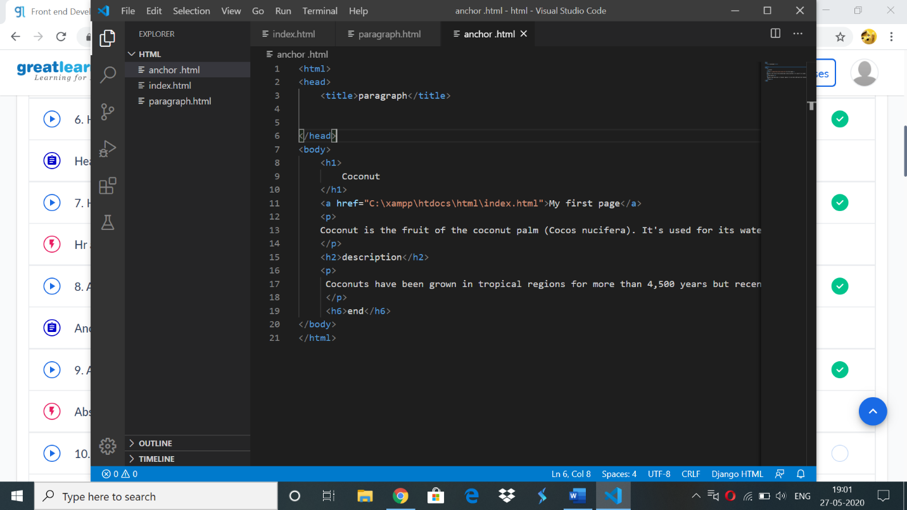

Online codding challenge:

1. #include <stdio.h>

#define MAXSIZE 10

void main()

{

int array[MAXSIZE];

int i, j, num, temp,c=0;

printf("Enter the value of num \n");

scanf("%d", &num);

printf("Enter the array elements \n");

for (i = 0; i < num; i++)

{

scanf("%d", &array[i]);

}

for (i = 0; i < num; i++)

{

for (j = 0; j < (num - i - 1); j++)

{

if (array[j] > array[j + 1])

{

temp = array[j];

array[j] = array[j + 1];

array[j + 1] = temp;

c++;

}

}

}

printf("Sorted array is...\n");

for (i = 0; i < num; i++)

{

printf("%d\n", array[i]);

}

printf("Num of iteration %d",c);

}

**OUTPUT**

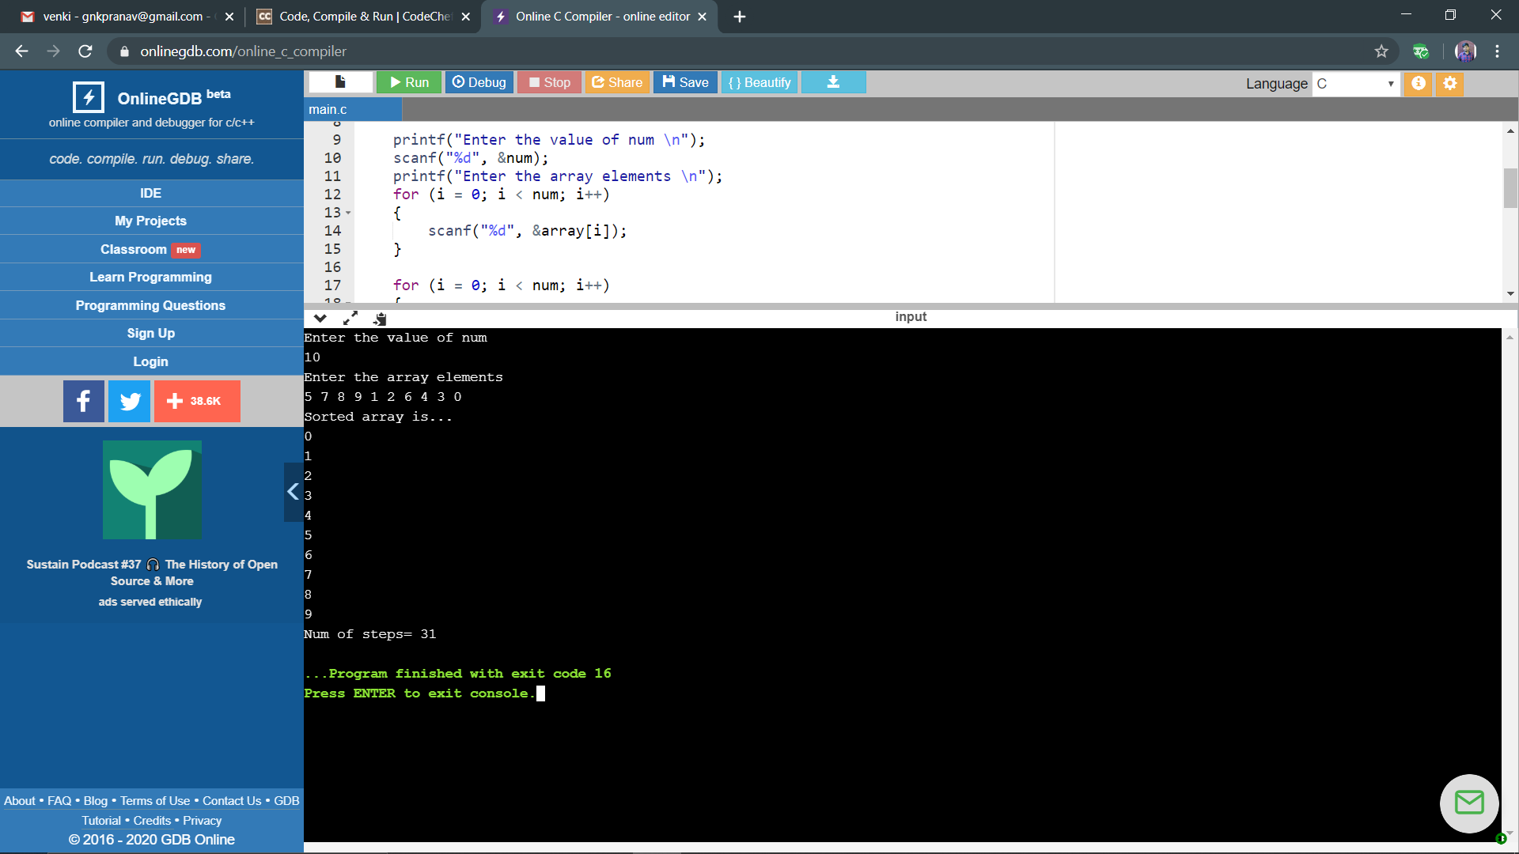

2)

